TITLE IN CAPITAL LETTERS AT 14 pt.
(this document is not an A4)
Author name at 12 pt

Section: Bold at 11 pt. (can be numbered or not)

Justified text body in Times New Roman at 10 pt. Single spacing. First paragraph line with indentation (tabulated) 10 mm. Footnote call with arabic flown numbers. The call will go right after the term to which it refers and before the point, or after the point if the entry affects the entire sentence or idea exposed. Courtesy line between paragraphs isn't reserved. Long dashes will be used –in this way–. Latin quotes will be used «preferably». In case of need in quotes, the following hierarchy will be used: « “ ‘word’ ”». QUOTES «When the quote has less than 40 words, it's written immersed in the text, between quotation marks and without italic».

Quotes that have more than 40 words are written apart from the text, leaving a courtesy line in Times New Roman at 9 pt. And spaced at 14 pt., with 10 mm indentation, without quotation marks and italic. At the end of the quote the point is placed before the content. The text omitted in a quote will be shown with square brackets […].

Sub-section: Bold at 10 pt. (can be numbered or not)
Quotes are made in this way: (Author, 2010, p. 74); (Author, 2010, pp. 74-78). The titles of works or artistic or cinematographic trends will be written in italics, as well as the expressions of other languages (f. ex. chiaroscuro).
TABLES AND FIGURES: Works with more than 2 tables or figures won't be accepted for publication in paper books (Option 1, in black and white) and 4 for the digital book (Option 2, in colour). These should always be sent in a separate file, correctly named and in jpg at 300 dpi. The images must be configured in panoramic format (12 cm wide x 5 cm high). Otherwise it could be modified for publication. They will be quoted in the text with consecutive arabic numbers: Figure 1 / Table 1 / Figure 1, etc. Below the image itself, the text should be configured as follows:

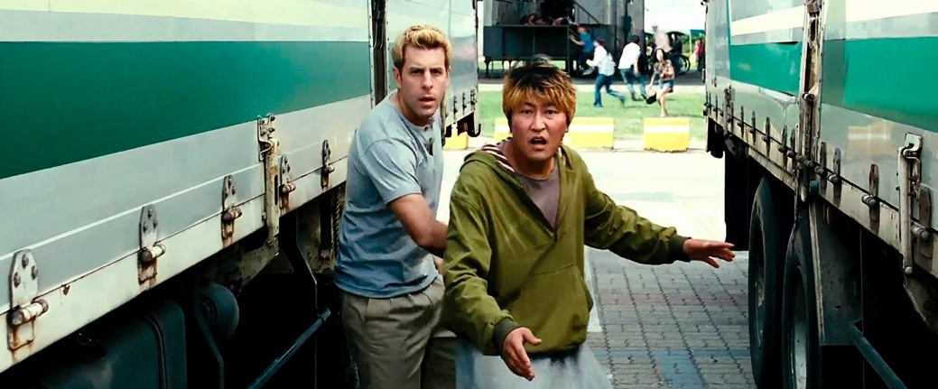

Figure 1: Times New Roman at 9 pt. Centered alignment.
Source: Author and year, Own elaboration, etc.

It is recommended and preferable not to use automatic translation software into English, as it detracts from the content and form of the text. In case of detecting this type of translation, the Editorial Committee will return the text for correction to the authors, before blind peer review.

List of references (Bibliography, Filmography, Ludography, Online Sources)

- Book: Surname, A. A. (Year). Title. City, Country: Publishing House.
- Book with editor: Surname, A. A. (Ed.). (Year). Title. City, Country: Publishing House.
- Ebook: Surname, A. A. (Year). Title. Recovered from http://www…
- Ebook with DOI: Surname, A. A. (Year). Title. doi: xx
- Book chapter: Surname, A. A., and Surname, B. B. (Year). Chapter title or the entry. In Surname, A. A. (Ed.), Book title (pp. xx-xx). City, Country: Publishing House.
- Periodical publications printed format: Surname, A. A., Surname, B. B, and Surname, C. C. (Date). Article title. Journal name, volume(number), pp-pp.
- Periodical publications with DOI: Surname, A. A., Surname, B. B. and Surname, C. C. (Date). Article title. Journal name, volume(number), pp-pp. doi: xx
- Periodical publications online: Surname, A. A. (Year). Article title. Journal name, volume(number), pp-pp. Recovered from http://www…
- Newspaper article printed: Surname A. A. (Date). Article title. Name of the newspaper, pp-pp. Or the version without author: Article title. (Date). Name of the newspaper, pp-pp.
- Newspaper article online: Surname, A. A. (Date). Article title. Name of the newspaper. Recovered from http://www…
- Thesis degree: Author, A. (Year). Thesis title (Undergraduate, master or doctoral thesis). Name of the institution, Place.
- Thesis degree online: Author, A. and Author, A. (Year). Thesis title (Undergraduate, master or doctoral thesis). Recovered from http://www…
- Reference to websites: Surname, A. A. (Date). Page title. Place of publication: Publishing House. Recovered from http://www…
- Sources in CDs / DVDs: Surname, A. (Year of publication). Title of the work (edition) [CD-ROM]. Place of publication: Publishing House.
- Films: Surname of the producer, A. (producer) and Surname of the director, A. (director). (Year). Name of the film [film tape]. Country: Production company.
- Television series: Surname of the producer, A. (producer). (Year). Series name [television series]. Place: Production company.
- Video game: Surname of the creator, A. (creator). (Year). Name of the video game. Place: Production or Developer company.
- Video: Surname of the producer, A. (producer). (Year). Name of the video [Source]. Place.
- Podcast: Surname, A. (Producer). (Date). Podcast title [Audio podcast]. Recovered fromhtpp://www…
- Internet forums, list of email addresses and other online communities: Author, (Day, Month, Year) Title of the message [Description of the form]Recovered fromhtpp://www…

In case of doubt or if there is a case that isn't contemplated in this template, there will be applied standards of APA 2019.

In case of attaching long URLs, it's advisable to shorten them:
https://www.lifewire.com/shortening-long-links-3486603
Texts may not exceed 5.000 words (including footnotes and final bibliographic references).

ANY TEXT THAT DOESN'T COMPLY WITH THE STANDARDS DESCRIBED IN THIS DOCUMENT, WON'T BE ADMITTED FOR THE PRINTED OR DIGITAL PUBLICATION.

Times New Roman at 8 pt. Minimum line spacing.

