TITLE IN CAPITAL LETTERS 12 pt.

Author's name at 12 pt
Affiliation

Paragraph: 11 pt. (may or may not be numbered)

Garamond 11 pt. justified body text. Line spacing 1/15 or 14pto. First line of paragraph indented by one digit. Call to footnote with arabic numerals . The footnote should be placed just after the term to which it refers and before the full stop, or after the full stop if the annotation affects the whole sentence or idea. No courtesy line is reserved between paragraphs.

Sub-paragraph: 11 pt. (may be numbered or unnumbered)
Garamond 11 pt. justified body text. Line spacing 1/5. First line of paragraph indented by one digit.

TABLES AND FIGURES: No more than 4 tables or figures will be accepted for for this digital book. These must always be sent in a separate file, duly named and in jpg at 300 dpi. The images must be in panoramic format (12 cm wide x 5 cm high). Failing this, they may be cropped for publication. They should be cited in the text with consecutive Arabic numerals: Figure 1 / Table 1 / Graph 1, etc. Under the image itself, the text should be configured as follows:
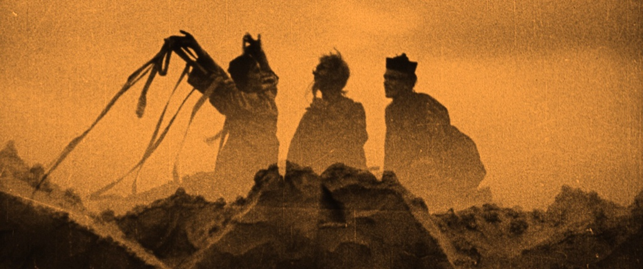
Figure 1: Garamond 10 pt. Alignment centred.
Source: Author and year, Own elaboration, etc.

Chapters should not exceed 4,000 words (including footnotes and final bibliographical references).

TYPOGRAPHICAL RULES:

In addition to following the APA 7th Edition (https://normas-apa.org/), the following considerations should be taken into account:

For the composition of texts
a) Set the typeface (its size) in Garamond 11, which must be maintained throughout the work.
b) Set the line spacing at 1/5 with equal criteria throughout the text, taking into account the necessary differences between the "body of the page" and the "notes", which will have a smaller size, although the same typeface will always be used.
c) Do not change the system of "indentation" of paragraphs, which will always follow the "ordinary" model: in each paragraph separated by a "full stop", the first word of the paragraph is indented by a "digit".
d) Bear in mind that spelling marks should always be of the same type - normal or italic - as the words to which they are attached. A blank space should always be left after each of them.
e) Ensure that the headings of each of the sections, sub-sections, etc., provided they are not explanatory text, are not closed with a "full stop", for aesthetic reasons.
f) Remember that italics must necessarily be used in the following cases:
- For non-English and words and expressions.
- For titles of works and journals, as will be explained later in the bibliographies.
- For neologisms, aliases, nicknames... or if you want to qualify the meaning of a specific word.
g) Be particularly careful not to lavishly, the purpose of which is not aesthetic but practical: so that the reader can better grasp what the author wants to express. That is to say, to highlight an article of a law, a title, etc.
(h) If necessary, an index of abbreviations should be provided immediately after the foreword, if there is one, or before it if abbreviations are already used in the foreword.
(i) Long quotations, longer than four lines, should be indented from the left margin. The text should be without inverted commas and in body size 11. Quotations of less than four lines must be enclosed in double inverted commas and in round ("quotation"), forming part of the body of the text.
If it is necessary to re-quote any word in the quotation, single inverted commas (' ') should be used. Range of headings: In each chapter, the range of internal headings should be done typographically following the outline:

CAPITAL LETTERS OR VERSALS (body 12)
VERSALS (body 11)
Italics
Round

Example:
EUROPE
SPAIN
Castile and Leon
Salamanca

For bibliographical references
a) In references to a specific work, the author's surname or surnames should be indicated first, in capital letters, followed by the initials of the author's name. (References to the same book may be made with the names of up to three authors, if applicable; if there are more, they should be presented as "et al.") in normal round letters. The complete title of the work should be in italics, but not - when they exist - the title of each of the volumes and volume number, which should always be in normal type. This should be followed by the number of the edition (only from the second edition onwards), publisher, place and date of publication (if available; if not, the s.l. and s.f. should be noted) and - if applicable - the specific number of the page or pages cited (always using the same abbreviation: p. or pp.). It is not necessary to include "Publisher": its registered trade name is sufficient.
Example:
ROQUETA BUJ, R., El trabajo de los deportistas profesionales, Tirant lo Blanch, Valencia, 1996.
b) In the case of a collective work, the title of the specific reference shall be enclosed in inverted commas and not in italics, with the addition of "en" and the general title of the work in italics, and all the rest as in paragraph a) for author's books.
Example:
CLEMENTE MEORO, M. E., "Régimen jurídico del arrendamiento urbano con opción de compra", in Estudios de Derecho Mercantil en homenaje al profesor Manuel Broseta Pont, Volume I, Tirant lo Blanch, Valencia, 1995, pp. 735-763.
c) For journal articles: author's name and surname as above, title of the article in unitalicised type between inverted commas and name of the journal in italics, indicating journal number, volume, date and page(s) cited, if necessary.
Example:
DE LA IGLESIA CHAMARRO, A., "Referendo y democracia",
Revista de Teoría y Derecho, 101, 3 January 2020, 35-54.
(d) When the same title and author are cited more than once in the same text, only the new data - generally the page(s) - should be included on successive occasions, and the abbreviation "cit." should be added after the title and author. In lower case and in normal type without inverted commas. If only one work by the same author is cited, it is not necessary to include the title: it is sufficient to add "loc. cit." or "op. cit.") or "ob. cit." or "obra citada", but in this case without italics. If the citations of the same work are successive, "idem" or "ibidem" or "loc. cit." in italics or "o.(bra) u.(ltimamente) c.(itada)" and "l.(ugar) c.(itado)", without italics.
Example:
STABLEFORD, B. , The A to Z of Fantasy Literature, Scarecrow Press, Plymouth, 2005, p. 198.

STABLEFORD, B. , op. cit., pp. 224-228.
e) Electronic resources: the inclusion of the reference of texts in electronic format in the bibliographic list is only mandatory when the document is only accessible online and is not published in a journal or book (including electronic ones). In this case, the citation must be presented as follows: surname(s) and first name initial of the author(s), title of the work, year of publication (in brackets followed by a colon), indication of the medium in square brackets ('[online]'), year of publication (in brackets followed by a colon, full address and availability, always starting with the hypertext transfer protocol (http) and enclosed in an antilambda and with a full stop after the closing antilambda (<>.), and date of query (in square brackets and with a full stop before the closing bracket).
Example:
ROMERO CARRASCAL, S.: "Archivos y delitos. La actuación de la Fiscalía de Patrimonio Histórico" [online], (2008), <http://www.arxivers.com/index.php/documents/formacio-1/jornades-d-estudi-i-debat-1/228-jed-080528-romero> [Accessed on: 01/09/2022.]
f) Although the abbreviations Confer = Cfr. and Vide = Vid. are equivalent, today we are increasingly tending to use Cfr. as a reference to a text with which to compare coincidences and discrepancies between what the author affirms and what we say. On the contrary, Vid. refers to a text in which the same thing is said that we defend or deny. In any case, these abbreviations will always be in italics, and the quotation must be complete the first time we refer to it.
Example:
GUNN, J. E. Paratexts: Introductions to science fiction and fantasy. Lanham, The Scarecrow Press, Inc., 2013, p. 123.

Cf. MARTIN, P. The Writer's Guide to Fantasy Literature: From Dragon's Lair to Hero's Quest: how to Write Fantasy Stories of Lasting Value. Waukesha, Writer Books, 2002, p. 35.

Example film:
LOW, S. (Director & Producer). (1995). Across the Sea of Time. [Film]. Sony New Technologies.

Example Game:
BETHESDA GAME STUDIOS. (2011). The Elder Scrolls V: Skyrim. [Video Game]. Bethesda Softworks.
g) For the bibliographies at the end of the work, always in alphabetical order of authors, the initial of their names will be placed after their surnames. Everything must be in capital letters. Prepositions or articles attached to the first surname are understood to be part of the surname for alphabetical order. Collective works, anonymous works, dictionaries, etc. are ordered according to the title.

Garamond 8 pt.

