Chapter title Minion Pro bold 16 pt. without full stop (recommended different from the title of the oral presentation)

Author’s name 12 pt.
Institution of origin 11 pt. italics

1. Headline 1: 12 pt. bold (numbered and without full stop)
This template has specific dimensions and margins and is the one that must be submitted for publication in English with Peter Lang. We don’t recommend copying content from other documents into it, as this could alter its formatting. Likewise, don’t include an abstract or keywords; the text must begin directly with the introductory section.
Body text justified in regular Minion Pro 10 pt. Line spacing 1/5. The use of explanatory footnotes is allowed, provided they are considered essential for the correct understanding of the text. Call to footnote with arabic numerals. The footnote must be placed just after the term to which it refers and before the full stop, or after the full stop if the annotation affects the whole sentence or idea. No courtesy line between paragraphs within the same section.
1.2. Headline 2: Minion Pro bold 11. (numbered and without full stop)
This template has specific dimensions and margins and is the one that must be submitted for publication in English with Peter Lang. Body text justified in regular Minion Pro 10 pt. Line spacing 1/5. The use of explanatory footnotes is allowed, provided they are considered essential for the correct understanding of the text. Call to footnote with arabic numerals. The footnote must be placed just after the term to which it refers and before the full stop, or after the full stop if the annotation affects the whole sentence or idea. No courtesy line between paragraphs within the same section.

1.2.1. Headline 3: Minion Pro italic 11 pt. (numbered and without full stop)
This template has specific dimensions and margins and is the one that must be submitted for publication in English with Peter Lang. Body text justified in regular Minion Pro 10 pt. Line spacing 1/5. The use of explanatory footnotes is allowed, provided they are considered essential for the correct understanding of the text. Call to footnote with arabic numerals. The footnote must be placed just after the term to which it refers and before the full stop, or after the full stop if the annotation affects the whole sentence or idea. No courtesy line between paragraphs within the same section.

TABLES AND FIGURES (IMAGES): No more than 1 black and white table or figure will be accepted for the publication of the book on paper (Peter Lang). Tables will be included in the body of the text as plain text. Figures must appear in the text at their designated locations and must also be submitted as separate files, properly named and in .jpg format at 300 dpi. Images must be in landscape format (12 cm wide x 5 cm high). Otherwise, they will be cropped for publication. They must be cited in the text using Arabic numerals: Figure 1 / Table 1, etc. Below the image itself, the text should be formatted as follows:

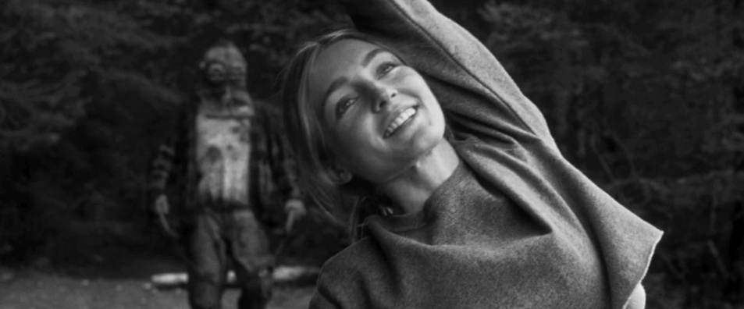
Figure 1: Minion Pro 9 pt. Alignment centered.
Source: Author and year, Own elaboration, etc.

Tables must be created in Word and embedded in the document. Each table must have a title and a number.

When you want to include a direct quotation, if it is short (less than 40 words), use inverted commas and keep it within the paragraph, as follows: “Lorem ipsum dolor sit amet, consectetur adipiscing elit” (Surname, year, p. xx). Please, leave a space after “p.” (or “pp.”). In the case of a long quotation exceeding 40 words, it shall be incorporated in a separate paragraph, separated by a courtesy line at the beginning and at the end, without inverted commas, without changing the typographical format and indented by one digit, in the following way:

Minion Pro regular 8,5. Lorem ipsum dolor sit amet, consectetur adipiscing elit. Maecenas venenatis, enim eget vulputate lobortis, quam leo luctus lorem, sed tristique nisi diam ut urna. Suspendisse non turpis ac erat venenatis porta luctus vitae elit. Nullam luctus nibh a tellus sagittis, sed ornare felis finibus. Sed a nulla at erat cursus congue sed ut quam. (Surname, year, pp. xx–xx)

This chapter, written in ENGLISH (Option 3, with Peter Lang), must not exceed 4.000 words (including footnotes and final bibliographical references).

FOR OTHER TYPOGRAPHICAL RULES NOT LISTED HERE:
APA 7th Edition must be followed (https://apastyle.apa.org/style-grammar-guidelines).

AN EXCERPT FROM A SAMPLE CHAPTER IS PROVIDED BELOW.

Questions From the Screen: Manifestations and Reflections of Art and Audiovisual Post-Production in Contemporaneity

Dr. Mario-Paul Martínez
Miguel Hernández University of Elche

Dr. Fran Mateu
Miguel Hernández University of Elche

1. Aesthetics of post-production
It is difficult to find on today’s screens any shot or scene that has not been filtered through the digital sieve or that, in this sense, has not been altered using computerized tools to enhance the result. From those scenes that greet us with their overwhelming special effects in cinemas (Pirates of the Caribbean, Avatar, The Avengers, etc.) or in video games (The Last of Us II, GTA V, etc.), to those that we open in the windows of web pages or social networks under the crudest of their design templates (such as the image filters of Instagram or TikTok).
The same could be said of another vast number of works that, being exhibited in different cultural circuits, such as museums or art galleries, configure their screens in a digital regime equally important as far as their plastic production is concerned. Whether in terms of their planning or aesthetic discourse, or in the way in which they relate to the viewer or the exhibition space itself. The immersive and multi-projection installations of creators such as Marina Nuñez, Rafaël Rozendaal or Tony Oursler would be, among many other examples, a direct sample of these forces and positions of digital post-production in contemporary art proposals. But, in the same way, so would be the paintings or sculptures by artists such as Albert Oehlen, Tony Cragg or Jeff Koons which, in principle, might seem alien to these digital screens, when in fact they contain a computer root in their sketches or in the works prior to their execution -when they are the direct method of their development-, equally relevant if we wish to understand the essence of these works.

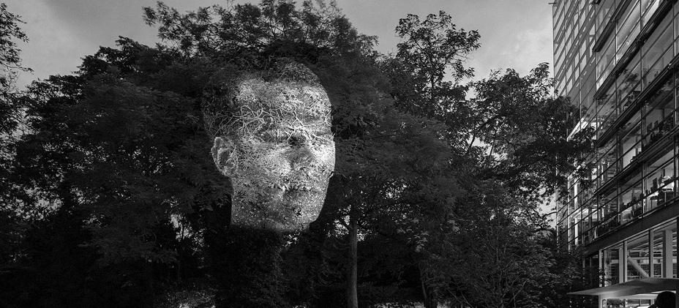
Figure 1: Eclipse. Tony Oursler (2019)
Source: https://tonyoursler.com

Based on these examples and qualities, it would be possible to point out two tendencies regarding the use (and the footprint) of digital post-production in the artistic and cultural field. The one that does not usually reveal the “tricks” that comprise its digital development; that is, that naturalizes them on stage, seeking their integration in a plausible construct or close to reality. And that which, at the other extreme, displays its pyrotechnics as the ostensible flag of the work itself, making digital post-production a shared boast between the message and the medium.
[…]
Lev Manovich would very lucidly call these audiovisual phenomena as “cinema-brush” (2005), referring to screen productions doped with post-production by digital software. Darley (2003) or Riambau (2001), extending these concepts to a broader plastic spectrum, would coin these modes under the terms of “cine-spectacle” or “concert films”. Underlining the relevance acquired by the digital in this kind of cinema, and its inherent relationship with the new means of entertainment and communication such as video games, Internet, virtual reality, etc. (Martínez, 2024), and proposing a scopic regime where the “digital visual culture” is the dominant one in the contemporary space.
But these are just some of the many examples cited in this preamble and in this book dedicated to shed light on this phenomenon of digital visuality -simple or baroque, covert or exuberant-, and dedicated to highlighting, in any of the cases, the importance of digital post-production as a medium and message of contemporary audiovisuals.
Having pointed out, therefore, these fundamental aspects of post-production through the computer, we should take a step beyond the questions that concern its typology or the development of its technique, to ask ourselves not only what these representations are or how they operate, but also what they are trying to tell us or express. In other words, what do the authors who make digital post-production the medium and/or the message of their own work intend? This is, in essence, the leitmotiv and the primary idea of the volume that the reader has in his or her hands: to expose the aspects and phenomenology of digital post-production through the cases and tendencies that contemporaneity brings us.
[…]
With The Screen is the Message, the title of our book in evident harmony with McLuhan’s sentence (which states that the way in which information is transmitted affects its meaning), we allude to this digital screen from which today we communicate, and process and post-produce most of our creations. That screen whose digital essence defines, as we pointed out, a good part of the ways of seeing and doing of today’s visual culture and, in this sense, a good part of our communicative relationship through these same processes and the results transmitted through its works of art. This is the title, in short, from which we intend to glimpse what are the manifestations and what are the antecedents that, from inside and outside the screen, have led us to this particular moment. And from which we intend to appreciate a plot of where the hybridizations and experiments that are going through the currents of audiovisual art, cinematography and its post-production formulas lead us, in a cultural space like the current one, where any image or video on the cinema or TV screen, or uploaded to the Internet and its social networks, goes through digital retouching or even through the corrections of Artificial Intelligence.
3. Bibliography

Darley, A. (2003). Cultura visual digital: Espectáculo y nuevos géneros en los medios de comunicación. Ediciones Paidós.
Lipovtesky, G., y Serroy, J. (2009). La pantalla global. Cultura mediática y cine en la era hipermoderna. Anagrama.
Manovich, L. (2005). El lenguaje de los nuevos medios de comunicación: La imagen en la era digital. Ediciones Paidós.
Martin, J. (2023). Teoría del arte y la cultura digital. Akal.
Martínez, M.P. (2024). En Espacio cinematográfico: de lo analógico a lo digital, edited by Arias, J.; Blanco, J.; Barba, D.; Llamazares, P. Ediciones Universidad de Valladolid.
McLuhan, M. (2009). Comprender los medios de comunicación: Las extensiones del ser humano. Paidós
Ortíz A. & Piqueras M.J. (1995). Painting in cinema. Paidós
Riambau, E. (2011). Hollywood en la Era Digital. De Jurassic Park a Avatar. Cátedra.

Minion Pro regular 9 pt.
Minion Pro regular 9 pt.
Minion Pro regular 9 pt.
Directed by Gore Verbinski (2003), James Cameron (2009) and Joss Whedon (2012), respectively.
Developed by Rockstar Games (2013) and Naughty Dog (2020), respectively.
“The medium is the message”, McLuhan (2009).

